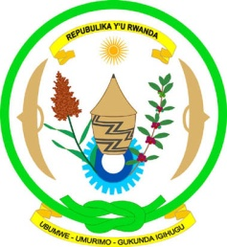

Republic of Rwanda
Ministry of Health

17 August 2019

Rwanda Remains Ebola Free

The Government of Rwanda wishes to reassure Rwandans, tourists and anyone planning to visit the country that no case of Ebola has ever been recorded in Rwanda and that comprehensive measures are in place to ensure that Ebola does not spread into the country.

Screening of persons entering the country has been intensified at all borders and airports. In addition, an Emergency Treatment Centre located in Rubavu District (which borders the DRC), has been established and equipped to effectively respond in an event of a confirmed case.

The Ministry of Health has, in partnership with the World Health Organisation, vaccinated 3,000 healthcare providers and other frontline workers as a precaution against any possible outbreak.

While Ebola has never been present in Rwanda, the country has continued to invest in a robust and effective healthcare system. Multiple simulation exercises have demonstrated Rwanda’s readiness to handle any disease emergency and the country is ready to deploy rapid response teams in the unlikely event that they are needed.

To find out more about how Rwanda is working to prevent the spread of Ebola into the country, visit www.moh.gov.rw.

Diane Gashumba
Minister of Health

